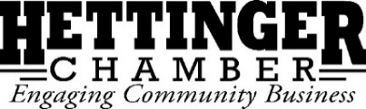
Board Meeting Agenda
September 16th, 2020 at 12:00pm

Call to Order:

Declaration of Quorum:

August 2020 Board Meeting Minutes:
Approval: 2nd:

August 2020 Email Meeting Minutes:
Approval: 2nd:

Financials
Approval: 2nd:
Committee Reports:
Rodeo: NDRA $1,000 received, Kling payout/purse split

Old Business:
New Building:
-Furniture: Assembly completed
-Exterior Paint: Needs trim work
-Roof: Progress
-Security System: Installed
-Technology: Scheduled Installation
Aux Cord/Speaker System: Finished
Jasmin Maternity Leave: Will be back early November

New Business:
Main Street Initiative Vibrancy Grant: Result, Intent
Student Director: Welcome Katrina Poss
New Board Member Search:
Health Insurance: Committee meeting September 10th
Tabletop Fliers/2021 Event Dates: Banquet, HHD, 4th, Rodeo, Pitchfork, Wake Up Santa
TRC: Pens, Signage
Payroll Tax Deferral:
Give Where We Live/Dacotah Bank:
WRHSF Donation Letter:

Next Meeting:
Date: ______________ ______, 2020 at 12:00
Location: CPO

Meeting adjourned:

