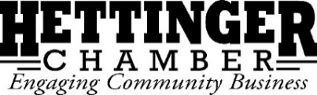
Board Meeting Agenda
Wednesday July 17, 2019 at 12:00pm
Community Promotions Meeting Room

Call to Order:

Declaration of Quorum:

Guests: Martin Kloster—mural design

Minutes:
Approval:

Financials:
Approval:

Committee Reports:
Marketing Hettinger:

Helping Hettinger Day: Follow Up

4th of July: Follow Up

Rodeo:

Pitchfork Fondue: Tshirts

Old Business:
General Membership Meeting Overview:
- Ambassador Program
- FAQ for New Members
- Board retreat

USDA Grant:

New Business:
Executive Report:

Chamber Sit In:

Ribbon Cutting Ceremony: Scruffy’s new ownership; Suzie’s changes

GoLocal! ND Recap:

Next Board Meeting:
Date:
Time:
Location:
Meeting adjourned:

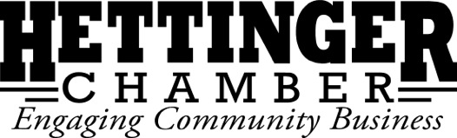

Executive Report: 7/17/2019
- Wired: Met Monday July 8th. Next meeting Monday August 12th.
- Armory Speakers: In Movies N’ More. What to do?
- Main Street Convening: August 21st in Hettinger. Please put on your agenda.
- Main Street Award Nominations: Nominate our projects & community leaders to put Hettinger on map. Nominations due July 30th. Here are the categories:
  - ND Legendary Heritage– for those who preserve & protect historical assets of their towns.
  - ND Arts and Culture– for those who promote and celebrate the arts and culture.
  - Revitalizer– for those who find creative, efficient uses for empty or dilapidated lots or structures
  - Legendary Young Leader– for a young North Dakota leader who has shown exemplary leadership in their community by speaking up, getting engaged and/or motivating others
  - Vibrancy – for communities that have activated space by investing in shared public space, cultural experiences and/or community events which draw residents and visitors.
  - Livability for All Ages– for a community, organization or project that provide a high quality of life for people of all ages.
  - Differentiator– for a community, organization, individual or project that has found an innovative way to attract businesses, workforce and visitors or enhance local quality of life
  - Future Leaders Empowerment– for a community that seeks to engage students in creating a healthy, vibrant community through leadership development, community planning or workforce
  - Main Street Excellence– multiple awards by population for communities with: Smart, Efficient Infrastructure; 21st Century Workforce; and Healthy, Vibrant Communities.
- Main Street Summit Sponsorship: Main Street communities are invited to sponsor a table in the Main Hall with a community themed table. It also includes complimentary admissions tickets, a vendor table in the Marketplace, and a picture in the community highlight presentation. 3 day tickets are $150 each, so it cuts ticket prices by more than ½.
  - $150= 2 tickets; $300=4 tickets; $500=6 tickets. Need decision.

Marketing Hettinger
- No meeting since before 4th & HHD.
- Fewer than 9 #ilovehettinger shirts left. Lots sold during 4th. Should focus on reaching alumni. Some suggested allowing reunions to pre-register.
  - Should begin working on new design.
- Social at the 4th: Good because we met people where they were, tough because of long day and trying to pull people from their families. Complaints they didn’t know about the event. Other feedback?
- Business Spotlights continue.
- Jed will begin construction on billboard in August.
- Please continue pushing Perks Cards. Overall, not a success for a number of reasons.

Helping Hettinger
- Event was far too close to the 4th. Not feasible to do again.
- Success despite rain. About 100 participants. Over 30 projects completed, though not all on that day.
- Over 200 registered for original event.
- Should consider having people complete their projects individually and sending in pictures rather than postponing next year.
- What to do with leftover t-shirts? About 50 remaining.

