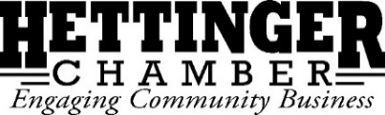
Board Meeting Agenda
September 7th, 2021 at 12:00pm
The Rural Collective & Via Zoom

Call to Order & Declaration of Quorum:

August Board Meeting Minutes:
Approval: 2nd:

August Email Meeting Minutes:
Approval: 2nd:

Financials:
Approval: 2nd:
Committee Reports:
Rodeo:
Pitchfork Fondue:

The Rural Collective:

Old Business:
PPP: Forgiven
Business Spotlight:
Sign on Main:
Board Vacancy:
Hettinger Merchandise Fundraiser:

New Business:
Community Welcome Incentive:
Career Day/Fundraiser:

Next Meeting:
Date: ______________ ______, 2021 at 12:00 pm
Location:

Meeting adjourned:

Upcoming Events:
- Tuesday Night Lights: Tuesday nights at 5:30
- Wired: Begins September 13th at 5:30pm
- Knitting Newbie Night: September 29th at 5:30
- Community Impressions Training: September 28th at 5:30; Trip to Crosby: October 1-2 or 3rd
- Design Your Succession Plan: October 18th, October 25th, November 1st from 6-9
- Coffee Flights Newbie Night: October 27th at 5:30

